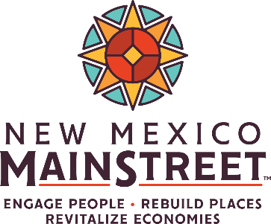
Technical Assistance Service Request Form
www.nmmainstreet.org | (505) 629-5270 | Return completed form to: Daniel.Gutierrez2@edd.nm.gov
New Mexico MainStreet‘s (NMMS) technical assistance supports the implementation of Economic Transformation Strategies (ETS) that spur economic growth and revitalization of NM’s MainStreet and Arts & Cultural districts (ACD).
NMMS/ACD programs are allowed two services annually in each of the Main Street Four Points (Economic Vitality, Design, Promotion, and Organization). Programs that demonstrate successful implementation of projects, events, and activities from previous service requests can request additional technical assistance if the appropriate Revitalization Specialist has availability. Please note that Revitalization Specialists may not be able to schedule an immediate on-site visit as they may have other request in their queue. While some services may be delivered wholly or partially on a remote basis, those requiring an on-site visit may take time to schedule, so plan accordingly.
If you have an urgent need, contact Daniel Gutierrez: (505) 629-5270 or Daniel.Gutierrez2@edd.nm.gov.
submission of this form indicates that board leadership has approved and supports this request.

Organization
Click or tap here to enter text.
Executive Director
Click or tap here to enter text.
Project Leader (if different)
Click or tap here to enter text.
Date
Click or tap to enter a date.
Email
Click or tap here to enter text.
Email
Click or tap here to enter text.

Phone
Click or tap here to enter text.
Phone
Click or tap here to enter text.

Project Description & Technical Assistance Requested
Which of the Four Points does this project best support? You can select more than one.
☐ Design
☐ Economic Vitality
☐ Organization
☐ Promotion
What is the title of the project associated with this request?
Click or tap here to enter text.
Describe the project for which you need technical assistance:
Click or tap here to enter text.
If requesting services for a business or building owner, please include:
- Name of business or building owner: Click or tap here to enter text.
- Business or building address: Click or tap here to enter text.
- Date of construction (for building design requests): Click or tap here to enter text.
- Approximate square footage (for building design requests): Click or tap here to enter text.
Have you contacted a NMMS Revitalization Specialist regarding this project? If so, who?
Click or tap here to enter text.
Describe the technical assistance or service requested:
You can use the “NMMS Technical Assistance Service List” as a guide or enter the service that was discussed with the NMMS Revitalization Specialist. Either way, please make sure you fully describe the scope of services you are asking for in this request.
Click or tap here to enter text.
When would you like the assistance to take place?
Click or tap here to enter text.

ECONOMIC TRANSFORMATION STRATEGY & OUTCOMES
What Economic Transformation Strategy does this project support?
Click or tap here to enter text.

What are the project’s expected outcomes?
Click or tap here to enter text.
How you will measure the project’s impact?
Click or tap here to enter text.

RELATED PLANNING DOCUMENTS
Identify any planning documents to which this request relates:
☐ Annual Work Plan
☐ District Master Plan
☐ Annual Assessment Report
☐ Readiness Assessment Report
☐ MRA Plan
☐ ICIP
☐ Design Charrette/Plan
☐ Economic Development Plan
☐ Cultural Economic Development Plan
☐ Other: Click or tap here to enter text.
Attach or upload a copy of the relevant page(s) from each document checked above.

